Regulations:
A14

H.T No

Sreenidhi Institute of Science and Technology
(An Autonomous Institution)
Code No: 4E201 Date: 08-Jan-2019 (FN)

B.Tech I-Year II-Semester End External Examination, Dec-2018/Jan-2019 (Supplementary)
Data Structures and C++ (Common to All)

Time: 3 Hours Max.Marks:70

Note: a) No additional answer sheets will be provided.
b) All sub-parts of a question must be answered at one place only, otherwise it will not be valued.
c) Missing data can be assumed suitably.

Part - A Max.Marks:20

Answer all QUESTIONS.

1. | What is an Abstract Data Type (ADT)? Write stack ADT. | [2M]
2. | What is a queue? What operations can be done on a queue? | [2M]
3. | What are the advantages of linked lists over arrays? | [2M]
4. | Represent the following binary tree using an array;  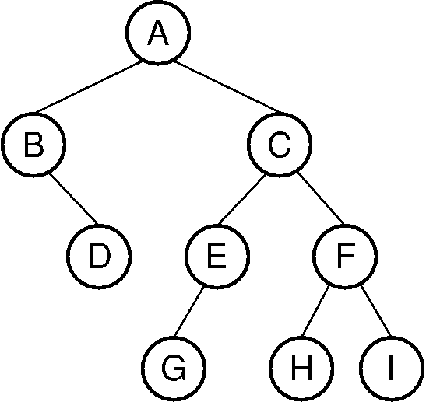 | [2M]
5. | What is depth-first traversal? Which data structure is used to perform depth-first traversal? | [2M]
6. | What is double hashing? | [2M]
7. | Consider the following array with exactly 15 elements:  1 2 3 4 5 6 7 8 9 10 11 12 13 14 15  How many comparisons that binary search requires to search the key element  when key=5? | [2M]
8. | Write the purpose and syntax of copy constructor. | [2M]
9. | What are the benefits of encapsulation? | [2M]
10. | When should you use a friend function? | [2M]
Part – B Max.Marks:50
ANSWER ANY FIVE QUESTIONS. EACH QUESTION CARRIES 10 MARKS.

11. | a) | What is a stack? Explain how stack is implemented using an array? | [6M]
 | b) | Convert the following infix expressions to postfix form using stack;  i) (C + D + A * B) * E + F  ii) A + B * C / D – E * F + G / H | [4M]
12. | a) | Write an algorithm to insert a new element into a single linked list at any position. | [5M]
 | b) | With a neat sketch, show how a queue can be represented using a linked list? Write algorithms for implementing queue using linked list. | [5M]
13. | a) | What is a binary tree? Find preorder, inorder and postorder traversals for the following binary tree.  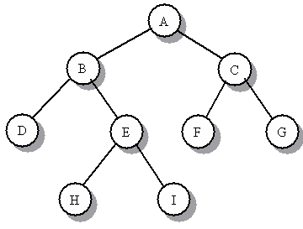 | [4M]
 | b) | What is an AVL tree? Explain insertion operation in an AVL tree. | [6M]
14. | a) | What is a hash function? Explain various hash functions with suitable examples. | [5M]
 | b) | Sort the following data using merge sort;  45, 85, 15, 55, 75, 25, 35, 65, 10, 90, 75, 67 | [5M]
15. | a) | Briefly explain object-oriented programming concepts. | [5M]
 | b) | What is a constructor? Illustrate default and parameterized constructors with suitable examples. | [5M]
16. | a) | What is the need for operator overloading? Illustrate with an example how binary operator can be overloaded? | [5M]
 | b) | What is inheritance? Explain multiple and multi-level inheritance. | [5M]
17. | a) | Write an algorithm to count the number of nodes in a double linked list. | [4M]
 | b) | Explain graph traversals with suitable examples. | [6M]
18. | a) | Write an algorithm for quick sort. | [5M]
 | b) | Explain with an example how to access the members of a class? | [5M]

-- 00 -- 00 –

